**Leveling**

**\*Most users do not need to do full-leveling when setting up their printer. Please make sure you follow the** [**calibration guide**](https://drive.google.com/open?id=1R4ggLXtaHLgEfPj2fK2P_7y7HjT0qA91M-NNgyH7Ak4) **for leveling before switching here**

Since there are slight variation in plate and vat, it is important to level before doing any print with resin. You should do leveling when you are changing vat

Folowing instruction is for firmware 1.15 or later. If you are not on firmware 1.15 yet, please upgrade first use firmware upgrade instruction here

<https://peopoly.dozuki.com/Guide/Moai+-+Firmware+Upgrade/3>

Leveling for Moai is very easy to do, please follow these steps:

1. Connect the power cable before turning it on
2. Install VAT (make sure push all the way in, Do NOT pour resin)
3. Install Built Plate (Make sure the knob on top is tighten)
4. Turn Moai on
5. Use the knob to turn. Press the knob to select “Setup”

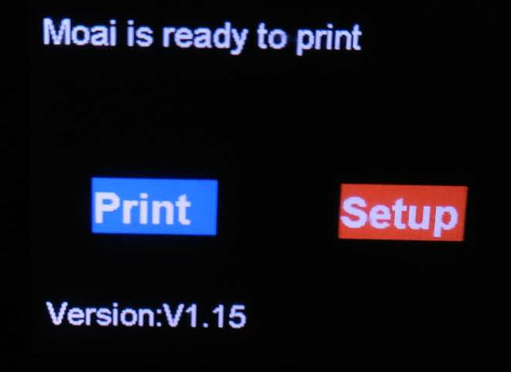

1. Go to the advanced_setting

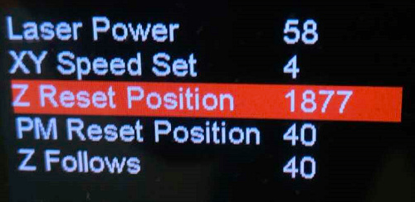

1. Change the **Z Reset Position to 1880**. Double press on the knob to exit menu. If it is already at 1880, turn to 1879 and then turn back to 1880 before double press. At this point **the build Plate should began descending** If there is any loud noise or Plate is going too low such it is hitting and keep press vat, press the power button off. Otherwise, just let it descent to print position.



*For FEP Vat users. The Z Reset Position should be set to 1815.

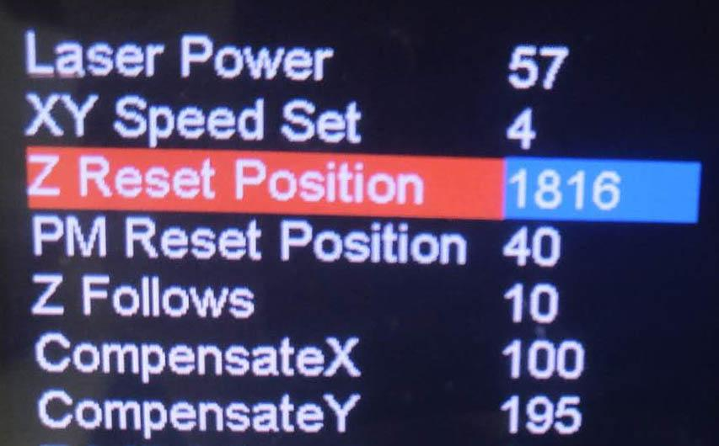

**It is very important that during step 7 that the build plate is lower into the vat before going to the next step**

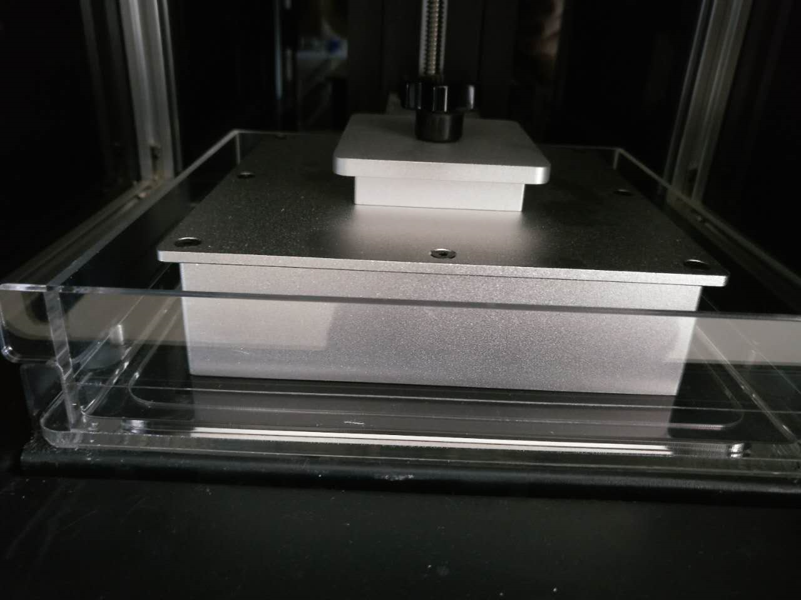

8. This is the key part of leveling:

There are 4 nuts/bolts right underneath of the VAT, and they look like this

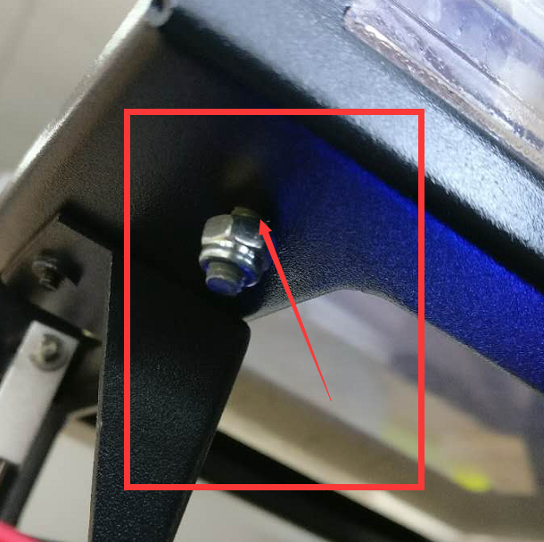

First, loose all four of them to a point that the nut to a point where you can see there is a gap between the nut and platform.(see above picture)

This is the tool to turn the nut when working:

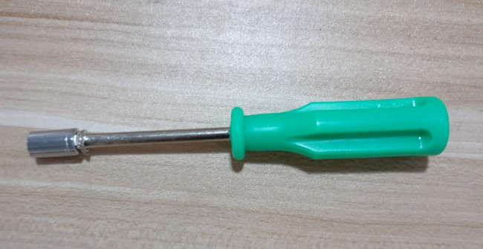

Then, tighten those nuts such that there is **NO** gap between nut and frame (nut just touching frame) but not press against it.(see below picture)

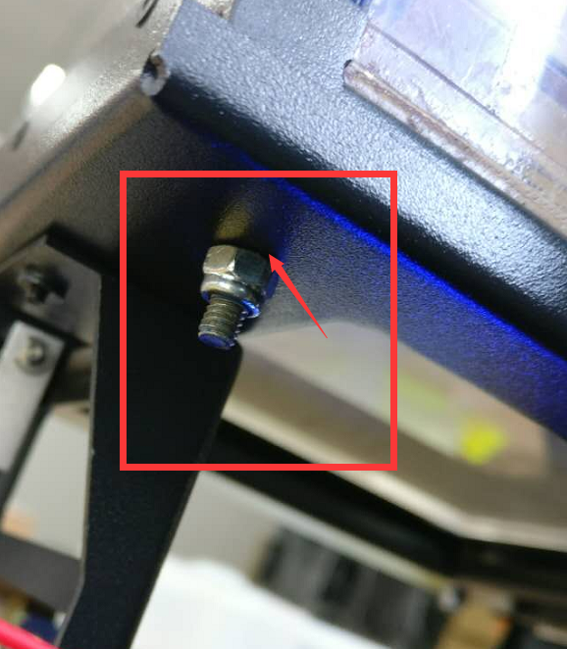

You can use a piece of paper to check the gap. If you can not slide the paper between the nut and the platform. It is good.

-

Once you are done.

Power Off the Moai by pressing power button

The power on Moai again

Go to Advanced settings and change Z-Reset Position from 1880 to 1877



*For FEP Vat users. The Z Reset Position should be 1816



Double press and the plate will drop down. You can go ahead and run the leveling test print in

The leveling section of [calibration guide](https://docs.google.com/document/d/1R4ggLXtaHLgEfPj2fK2P_7y7HjT0qA91M-NNgyH7Ak4/edit?usp=sharing) and further calibrate your level heights.

Leveling video: <https://www.youtube.com/watch?v=652Kjil-sk8>

(*need update)

-

For micro adjustments in case you need it:

Tightening the nut lowers the vat.

Loosening the nut raises the vat.